***Letter Head.***

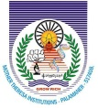

**Mother Theresa Institute of Computer Applications**

**Melumoi, PALAMANER - 517408**

**PHNO: 08579 268585 Email :: mtimca@gmail.com**

Courses Offered :: MCA, MBA, B.Ed., D.Ed., Degree :: Bsc [ MECS, MSCS, MPCS] Bio-Tech, Bcom Computer Applications, Engineering Streams : ECE, CSC, EEE, Civil, Mechinical